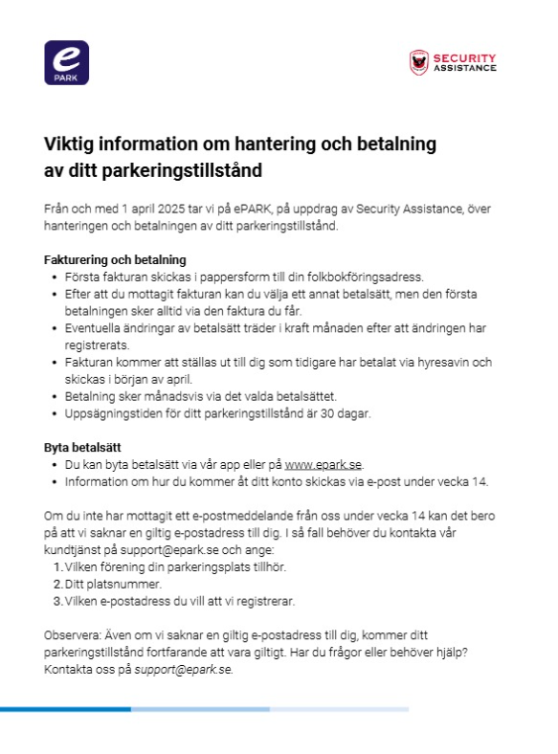

KONTAKT:
Security Assistance Parkering: 040-689 24 85

