BRF Björkskatan gives information regarding waste

Together we do as much waste sorting as we can

For the environment, economy and our well-being
We believe that it is essential that we together create a good and safe environment in our neighborhood. One piece in this creation is to have environmental rooms (Miljörum) where we separate waste in a right manner. Besides being good for the environment it is also good for the economy of our association. With a proper waste sorting we may be able to save as much as 80 000 kr/year. That amount is actually how much extra we have been paying for inadequate waste sorting during 2024.
What should we then do?
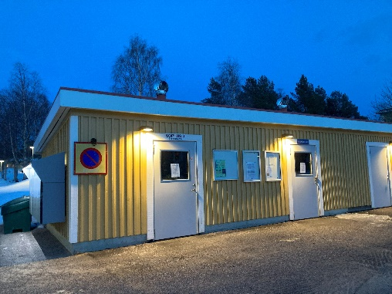
- In the environmental rooms (Miljörum/Sophus)

Separate waste in the different waste fractions available in the environmental rooms.
Lumire, the municipal waste company, empties the barrels.
Look at the sorting scheme from Lumire regarding what waste fractions that are available and what is included in each fraction. The sorting scheme can be found at the environmental rooms.
The better we are at sorting food waste, paper, small electronics, batteries, light sources and different kinds of packaging consisting of paper, metal, plastics and glass, the less waste will remain in the residual waste. The meaning of source separation is to get a high degree of reusable materials. A higher degree of reusable materials is better for society and the environment. In addition, the residual waste has a higher cost for our association compared to the source sorted materials.

Please do not leave waste that cannot be source sorted in the environmental rooms! If there is no barrel for a specific waste fraction in the environmental rooms it should not be left there. If waste happens to be found in a wrong barrel we will have to pay an extra fee for wrong waste sorting. If we put waste outside of the barrels we will have to pay HSB Service to collect and transport the waste to Risslan (recycling center). Wrong sorting will cost our association extra.
- To recycling centers (ÅVC)
You can bring waste that cannot be left in the environmental rooms to a recycling center. Risslan is such a center. There is also a small recycling center in the city (Returpunkt Centrum). At this center it is possible to hand in:
- Spray cans (hairspray, painting spray etc). Spray cans are often classified as hazardous waste.
- Hazardous waste in small packaging (e.g. some paintings, nail polish, solvents etc)
- Metal (that are not packaging)
- Small electronics (you can bring small electronics of a bit larger size than can be handled in the environmental rooms at our association)
- Waste textiles
- Crockery and glass (that are not packaging). We have had this fraction in our environmental rooms before, but due to bad separation the fraction is no longer available to us. If we step up regarding waste sorting we might be able to get the fraction back again…

- Bulky waste – in containers spring and autumn
It is possible to leave furnitures and other bulky wastes in containers that our association provides in spring and autumn. It is, of course, possible to transport the waste by your own effort to a recycling center like Risslan, but our association provides two occasions annually to get rid of such waste. Please store your bulky waste in an appropriate place until the collecting occasions. Information will be given in advance to the collection periods.
There are certain wastes that you are not allowed to leave in the bulky waste containers. Among these wastes are hazardous waste, tires and electronics. Such waste you have to take care of on your own and leave at a recycling center or another approved waste receiver.
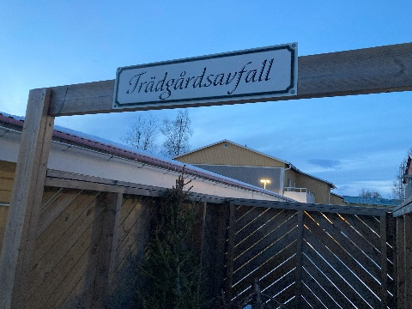
- Garden waste in bins next to environmental rooms
During the summer part of the year it is possible to leave gardening waste in the bins next to the environmental rooms. The bins have each a sign ”trädgårdsavfall” and can be found at the lower environmental room on the uneven side and at the upper environmental room on the even side. HSB Service provides the emptying of these bins.

